🚀 Automatically Generate Architecture Diagrams using Amazon Q CLI and MCP Servers

Make sure your machine is updated and has Libfuse2 installed
- sudo apt-get update
- sudo apt install libfuse2
Install the deb file for Amazon Q
- curl --proto '=https' --tlsv1.2 -sSf https://desktop-release.q.us-east-1.amazonaws.com/latest/amazon-q.deb -o amazon-q.deb
Install Amazon Q debian file

- sudo apt install -y ./amazon-q.deb

Login into Amazon Q developer by creating a BuilderID here followed by command
- q login

once you have logged in, just write simple command
- q

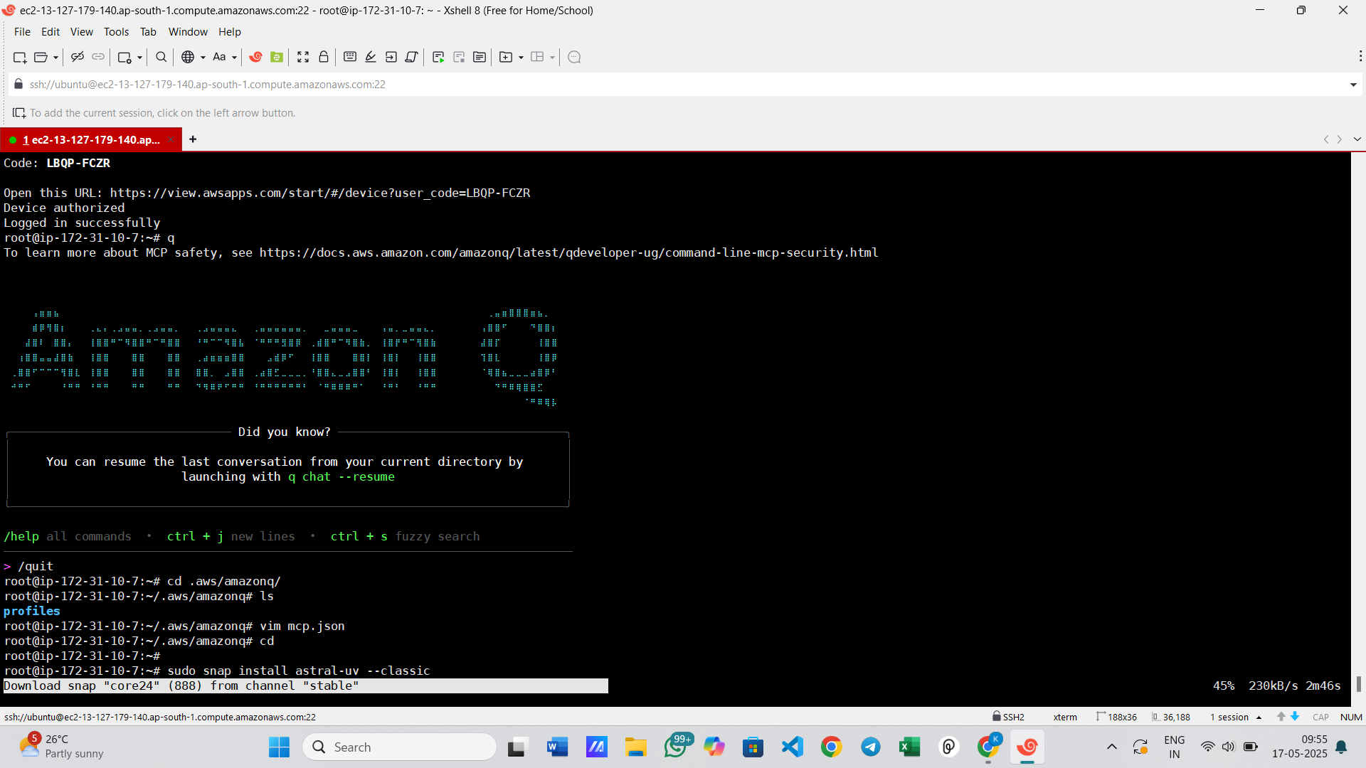

MCP Support on Amazon Q CLI

Now let's power up your Amazon Q CLI with MCP Servers.
You need uv to install and Run MCP Servers
- sudo snap install astral-uv --classic
- Now create a file called mcp.json in ~/.aws/amazon
and add this:
{

"mcpServers" : {

"awslabs.cdk-mcp-server": {
"command": "uvx",
"args": ["awslabs.cdk-mcp-server@latest"],
"env": {
"FASTMCP_LOG_LEVEL": "ERROR"
}
},
"awslabs.aws-diagram-mcp-server": {
"command": "uvx",
"args": ["awslabs.aws-diagram-mcp-server"],
"env": {
"FASTMCP_LOG_LEVEL": "ERROR"
},
"autoApprove": [],
"disabled": false
}
}

}

Now run q again:
You are all set now!

